International Politics – Lesson Plan Resources by Grade Level
The National Standards for Social Studies Teachers provides a broad framework for expected competencies for the multiple disciplines that fall under the umbrella of social studies, including politics. As a field that’s heavily influenced by other disciplines, such as psychology, culture, civics, and history, the study of politics begins with basic foundational concepts in the early grades and gradually evolves to a cross-disciplinary understanding of the international political landscape.
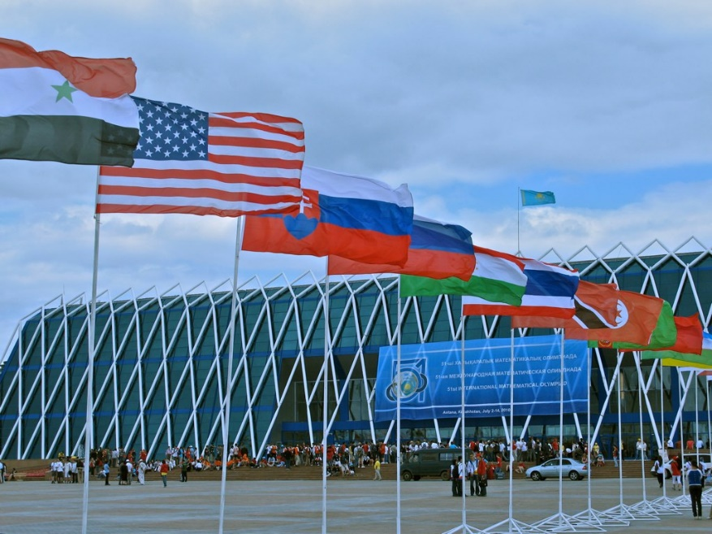
Image via Flickr by Mathematical Association of America
Resources for National Standards in Related Disciplines
The study of international politics crosses multiple disciplines. Teaching international politics in the younger grades begins with a local emphasis and the study of foundational concepts encompassing history and geography. Teachers should familiarize themselves with the various disciplinary standards and how the study of international politics relates to the common core at each grade level.
National Standards for Social Studies Teachers
The National Standards for Social Studies Teachers, last updated in 2002, reflects the influence of politics across disciplines such as civics, history, and government, underlying disciplines such as geography, and the role of politics in other disciplines, such as economics. Source: SocialStudies.org
National Standards for Civics and Government
The Center for Civic Education outlines the National Standards for Civics and Government. Source: Center for Civic Education
National Standards for History Basic Edition
Visit the National Center for History in the Schools for the National Standards for History Basic Edition, 1996, as well as Historical Thinking Standards, U.S. History Content Standards (for grades 5-12), World History Content Standards (for grades 5-12), and Standards for K-4. Source: National Center for History in the Schools.

Grades K-4
In grades K through 4, students begin to learn that countries are governed by groups of leaders in various structures. In the early educational years, students learn about U.S. politics as a framework that is later expanded to compare and contrast political structures on an international level.
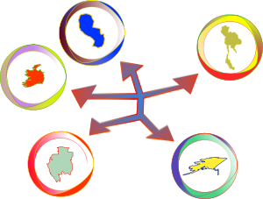
Image via OpenClipArt.org
U.S. Government and Citizenship
Why Vote? A Public Awareness Campaign
Targeted to students in grades 3 through 5, this lesson teaches students the importance of voting. These activities are easily modified to add complexity for use with higher grade levels. Students conduct internet research, learn about local government, and list reasons for voting in elections. Source: The Democracy Project by PBS Kids
Declare the Causes: The Declaration of Independence
Through role play, creative writing, discussions and other activities, students in grades 3 through 5 learn about the development of the Declaration of Independence. Students will develop an understanding of the complaints that led to the Declaration of Independence, be able to describe the parts of the Declaration, and understand it in the context of its historical significance. Source: National Endowment for the Humanities
“The True Story of the Three Little Pigs”
This lesson builds on a relatable concept to engage students in K through 2nd grade and convey the concept of voting. Students will learn the importance of having a voice and using the right to vote to influence outcomes. Source: Hotchalk Lesson Plans Page

Leadership and Authority
What is Authority?
After completing “What is Authority?” students in grades 1 and 2 will have an understanding of authority and the concept of limited government. This is an essential cornerstone of the study of international politics – developing an understanding of why societies need leadership as well as a framework for comparison. Source: The Center for Civic Education
Local and State Governments
For students in grades K through 3, this lesson prepares students with an understanding of local and state governments, the role of elected officials, and how laws may differ between local governments, state governments, and federal governments. Additional resources are offered as suggestions for scaffolding these materials for further applications. Source: BrainPOP Educators
Looking for Lincoln Throughout His Life
This lesson will take two 45-minute class periods, highlighting former President Abraham Lincoln and his contributions to society today. Addressing the standards of chronological thinking and obtaining and interrogating historical data, this lesson is ideal for students in grades 3 through 5. Source: PBS.org

Global Society, Gender and Culture
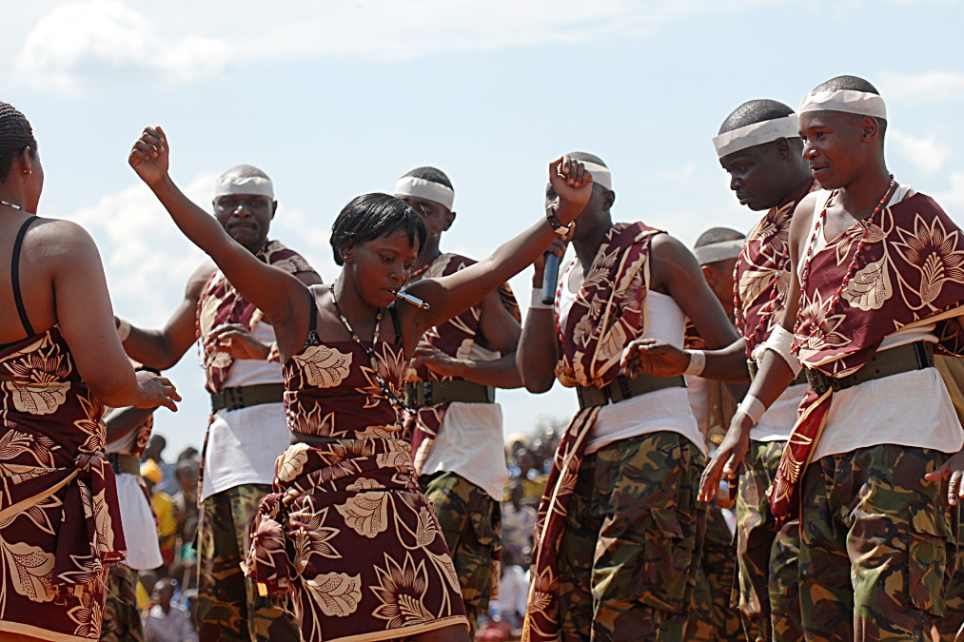
Image via Flickr by U.S. Army Africa
The Flow of Women’s Work
“The Flow of Women’s Work” is geared towards students in K-2 and 3-5 grade levels, providing a contextual understanding of how gender roles are established in different societies. Students compare water-related work in rural Lesotho with their own households. Students will learn that geography and traditions have an influence in gender roles, and understand how attitudes about gender roles differ in various cultures around the world. Source: Peace Corps
Pennies for Peace
The “Pennies for Peace” toolkit is a set of lessons and educational resources for teaching students in grades K through 4 the fundamentals of cultural diversity and citizenship, as well as the importance of political and nonpolitical developments in the U.S. and other nations, and the desire for community, stability and peace in the international context. Source: Pearson Foundation
Kindergarten History
A full, standards-based curriculum outline complete with lesson plans, printable worksheets and additional resources, this Kindergarten History collection from Rockingham County Public Schools is an exceptional resource for kindergarten teachers who want a gamut of sequential activities and lessons that will prepare students for a rich, multi-disciplinary study of international politics throughout their educational careers. Source: Rockingham County Public Schools

International Relations
The Middle Ages
Students in the younger grade levels begin the study of international relations and international politics by first learning that different countries have different cultures, government structures, and have been influenced throughout the course of history like the U.S. “The Middle Ages” addresses a critical period in the development of European culture, introducing students to the idea of class structures including lords, knights, and ladies, as well as the difference in opportunity and education offered to different societal classes. Source: Discovery Education
Elementary School Level [K-5] Curricular Materials Developed for the CGS
This is actually a set of lessons addressing foreign cultures and the relationships between the U.S. and multiple international governments. Lessons cover Japan, China, The Middle East, Ireland, and broader lesson plans that foster an appreciation of cultural diversity. Source: The Center for Global Studies, Penn State University
Current Events
This lesson in current events meets students at their level, first fostering an interest in different countries around the world and their locations. Students are assigned a country and will learn to use encyclopedias and other resources to research information including culture, geography, population, size, location, symbols, and other important identifying information. Source: The Academy Curriculum Exchange

Grades 5-8
In grades 5-8, students have shifted from learning to read to reading to learn, enabling them to read for comprehension and develop a deeper understanding of the role of governments and how the world’s nations interact and influence one another.
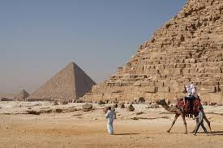
Image via Wikipedia.org
U.S. Government and Citizenship
The Role of the First Congress in Our Federal Government
The Institute for Public Administration at the University of Delaware provides a thorough unit consisting of eight lessons to provide students with an understanding of the role of Congress. The unit is designed to coincide with a mock Congress, creating an engaging experience for students. This unit can be used with students in grades 6 through 12. Source: University of Delaware Institute for Public Administration
President for a Day
Students in grades 6 through 8 explore the roles and responsibilities of the President of the United States in this interactive lesson plan. Students will also delve into topics such as the system of checks and balances established by the Constitution, the principles of American Democracy, and foreign policy. Source: PBS LearningMedia
Project Citizen
Project Citizen is a comprehensive approach to teaching students how they can monitor and influence public policy in their local communities. This particular lesson represents a portion of the program targeted to middle school students, in which participants will examine community problems, identify solutions, and propose new public policies they believe the government should adopt. There’s also a resource for obtaining full copies of the student text and access to the entire sequence of educational activities and materials. Source: Center for Civic Education

Leadership and Authority
Who Rules?
In “Who Rules?” students will learn about the various types of government and how other countries around the world are governed in different ways. Students will compare and contrast oligarchy, democracy, autocracy, and other government structures, and study real-world examples around the world today. Source: iCivics
Advising the President – Student Cabinet Activity
Students gain an understanding of the complex structure of leadership and authority within a Democratic government, using the U.S. as an example. An interactive and engaging lesson, students form a mock Cabinet to advise the President and learn about the executive branches of government. Source: Teaching Civics
Indian Education Curriculum
The Minnesota Department of Education offers a variety of lesson plans surrounding the American Indian culture, sovereignty, values, leadership within the culture and other important topics for gaining an understanding of the Indian culture that exists in harmony within the broader context of the U.S. government, and how the two groups maintain agreements and coexist peacefully. Source: Minnesota Department of Education

Global Society, Gender and Culture
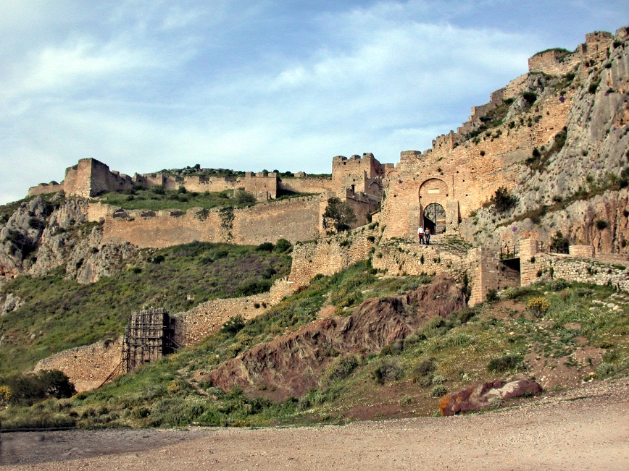
Image via Wikipedia.org
Comparing Athens And Sparta
In this lesson, designed for students in grades 6 through 8, students will learn the difference between totalitarianism and democracy by studying Athens and Sparta in a historical context. Students gain an understanding that both forms of government exist in the modern world, each having roots in ancient Greece. Modifications are included to make this lesson more complex for upper grade levels. Source: Discovery Education
The Hidden History of Egypt
Students in grades 6 through 8 delve into the life and culture of Egypt, including religion, farming and other lifestyle considerations, entertainment, writing and hieroglyphics, and significant symbols associated with Ancient Egypt. This lesson addresses several standards, including power, authority, and governance; individuals, groups, and institutions; and global connections. Source: Discovery Education
Lesson on Ethnic Discrimination
Students learn to define ethnicity, develop an understanding of ethnic discrimination in the global community, and positive steps being taken and that students can take to eliminate ethnic discrimination through the use of concept maps, discussions, and journaling about their own ethnic backgrounds and how their individual backgrounds have influenced their identities. Source: United Nations Cyberschool Bus

International Relations
Remembering 9/11: Building Tolerance
Students examine the events of 9/11 and those leading to it, as well as the impacts of 9/11 over the following days, months and years through a critical analysis of news media. In doing so, students also learn the parts of a news article and the significance of a free press in a democratic society – along with identifying unifying factors in a diverse society and legal issues resulting from 9/11 and other terrorist attacks. Source: Share My Lesson
Ocean and Sea Borders
Students evaluate the problem of determining which countries maintain the rights to mutual-border resources, such as the North Sea. In this engaging activity, students will actively determine rules for dividing the North Sea’s resources and create a map allocating those resources to the designated countries. Source: National Geographic Education
Setting a Higher Bar: Global Exchange’s Fair Trade Cocoa Unit for Kids
Students gain an understanding of Fair Trade and how it exists and functions in the modern world. The lesson is positioned within the context of chocolate trade, facilitating discussions and understanding of how consumer choices impact countries and civilizations around the world. With various activities and instructional approaches, this multi-disciplinary lesson touches on language arts, social studies, art, math, and life science. Source: GlobalExchange.org – Fair Trade in the Classroom

Grades 9-12
In the upper grades, students can begin to apply previous information learned to more complex scenarios and conduct critical analysis of the impacts of various factors on the world, on relations between countries, on politics, and on societies. Students can also take foundational knowledge and apply it to their own theories and predictions.
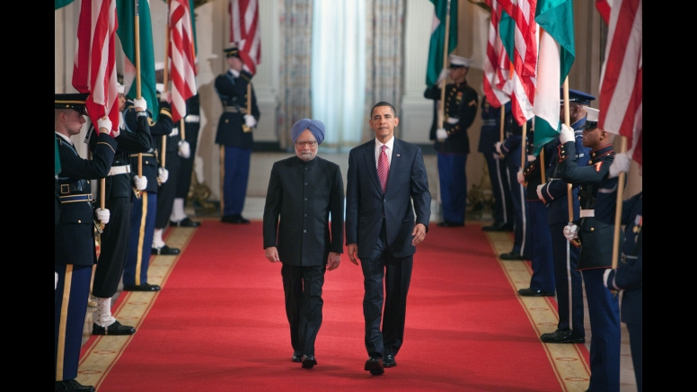
Image via Wikipedia.org
U.S. Government and Citizenship
Cyberattack Detection Versus Privacy Protection
Teachers can engage students with current events with this lesson plan, in which students will participate in roundtable discussions, research and prepare essays with their points of view on the Fidnet plan and whether a personal privacy sacrifice is a reasonable tradeoff for protection against cyberattacks. Source: The New York Times - The Learning Network
People Power – Engaging Citizens to Change the World
This series of lessons relies on a multi-media approach to engage students in the study of citizenship and how the collective power of populations can influence change. Using instructional strategies aligned with the Common Core Standards, People Power fosters an understanding of democracy, promoting change, and the effectiveness of nonviolent strategies to initiate change in local and national contexts. Source: CivicVoices.org
Appreciating Democracy: A Lesson Plan for High School Teachers of Civics, Government, and U.S. History
This lesson can be conducted in three to four 45-minute class periods. Students will learn the practices of democracy in the U.S., understand and appreciate the idea that different people have different values, beliefs, and interests. It culminates with the concept of compromise and majority vote used in legislation to debate issues and come to conclusions. Source: Washington State Legislature

Leadership and Authority
George Washington: The Living Symbol
Students in grades 9 through 12 will develop an understanding of George Washington’s path to the presidency, become familiar with his writings, and understand his influence and various meanings that have been attached to his name throughout history. Source: National Endowment for the Humanities
Mandela: Long Walk to Freedom
Students learn the qualities of leadership through the study of Nelson Mandela’s trial and how the former South African President led the country towards democracy. Students will watch a video and think critically about Nelson Mandela’s actions, approach to leadership, and the traits that made him an effective leader, as well as analyze other leadership scenarios to identify leadership qualities. Source: The Weinstein Company
Politics in Puerto Rico: 1900-1930
This lesson delves into the political parties of the 1930s, the political leaders, their beliefs and values. Students will compare and contrast the political parties of the 1930s with the political parties of today, and learn how political leaders guided and influenced Puerto Rico. Students will learn how writers reflect the political influences of their times. Finally, students will gain an understanding of the reasons behind the emergence of new political parties. Source: Character Education Partnership

Global Society, Gender and Culture
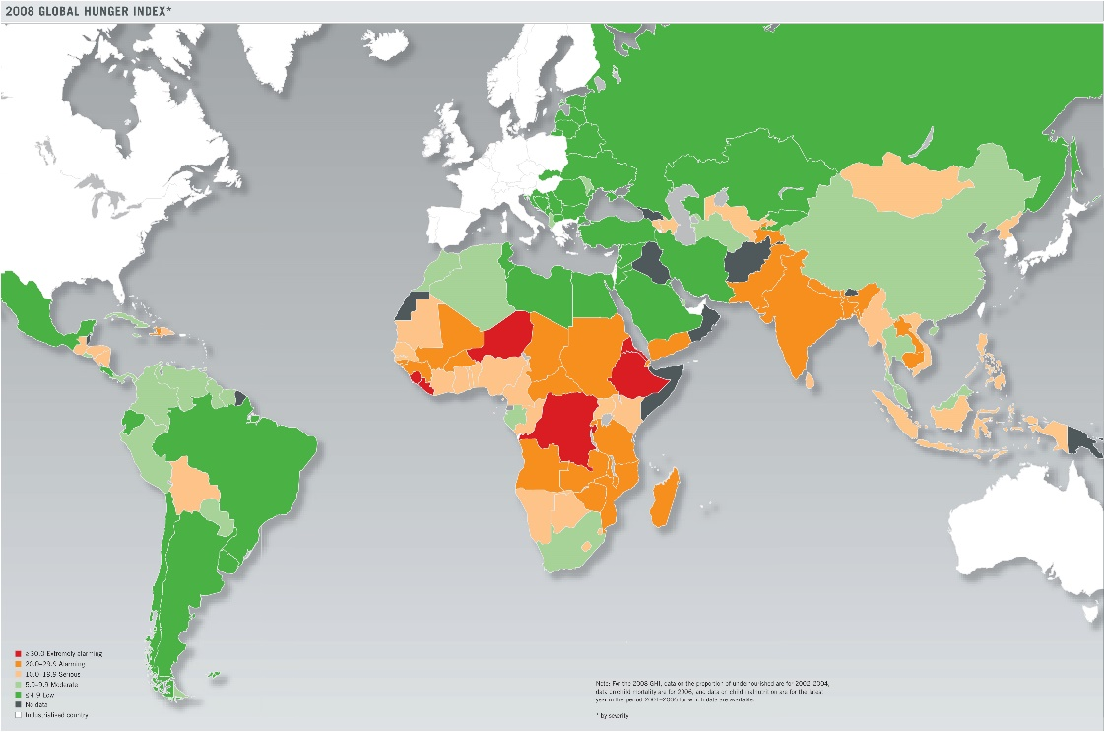
Image via Wikimedia Commons
2013 World Population Data Sheet
The Population Reference Bureau provides activity suggestions that make use of PRB’s 2013 Word Population Data Sheet (updated annually) that can be used for grades 6 through 12. You can also access some interactive graphics based on the same data for computer-based activities and more sophisticated analysis in the upper grade levels. The activities range in complexity from comparing and contrasting countries based on geographic and demographic information to more critical analysis and data mapping. Source: Population Reference Bureau
What is Culture?
This lesson plan is targeted to 9th grade students, designed to create a foundational understanding of culture upon which international relations studies can be built. A rich, interactive lesson, students will break into group sessions and conduct a critical analysis of different cultures, thinking critically about the differences and similarities between cultures as well as the beliefs of the group studied, rules and purposes, as well as whether membership is voluntary or involuntary. Source: Mr. Donn’s Social Studies Site
World Hunger
From a variety of perspectives including family, local, community, and global, students examine global and local events and practices and their impacts on food choices and availability. Students learn about disadvantaging conditions that impact accessibility and quality of food options, and the effects of public policies, agencies, and institutions on the family unit. Source: Family, Career and Community Leaders of America

International Relations
Rewrite the Script of Imperialism
“Rewrite the Script of Imperialism” is a full unit designed for high school students, although modifications make it workable for middle school students as well. Throughout this unit, students will gain an understanding of imperialism, the impacts of colonization, the relationship between wealthy and undeveloped countries and much more through a series of readings and interactive activities. Source: BetterLesson.com
War Making: Executive and Legislative Powers
Students examine the constitutional, legal, political, and historical sources influencing the debate on executive and legislative powers in creating war. Students examine significant events both present-day and historical, facilitating discussions and understanding both of U.S. Government branches and international relations. Source: National Constitution Center
International Alliances
Students will study six international alliances, including their history, mission, and function. Students will be able to identify and list reasons why countries would want to form alliances with one another, mark the geographical range of the six international alliances on a map, research viewpoints of each respective group, and the roles these organizations play in international relations. Source: National Geographic Education

Additional International Politics Lesson Plan Resources for Teachers
The following resources provide collections of lesson plans, either as stand-alone lessons that can be integrated with other instructional activities or full units consisting of sequential lessons to facilitate an understanding of a broader concept.
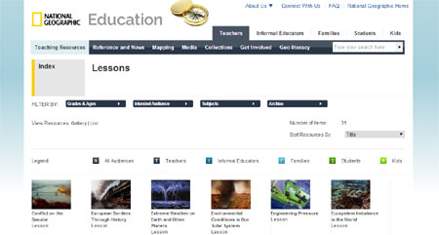
Image via National Geographic
Civic Education Lesson/Unit Plans
The University of Delaware’s Institute for Public Administration has a set of lesson plans, including teacher’s resource guides, printable worksheets and other materials for use with different grade levels. These lessons are aligned with civics standards and cover topics such as citizenship, government, democracy, elections and related topics. Source: The University of Delaware

The Learning Network – Teaching and Learning with The New York Times
The New York Times showcases a common core-aligned lesson plan or activity every week that can be put to use in the classroom. Based on current events, these lesson plans help students grasp important global happenings that impact the world economy and political landscape. Here’s an outline on how these lesson plans can be used in the classroom. Source: The New York Times

Facing the Future: Global Sustainability Curriculum & Teacher PD
With a focus on global sustainability, Facing the Future offers a wide variety of lesson plans and units aligned with standards in multiple disciplines, such as social studies, language arts, geography, and more. Additionally, teachers may opt to purchase other lesson plans at varied price levels, covering language and literacy, population, global issues, conflict and consumption, and related areas of study. Source: Facing the Future

National Geographic: Education
National Geographic is a plentiful source of valuable articles, videos, and other media as well as complete lesson plans and units encompassing a variety of cultural, societal, and other international topics. The collection is searchable by audience, subject, and grades and ages, so it’s easy to locate lessons in line with your curriculum. Source: National Geographic Education

The Gateway – Social Studies
This searchable database includes a variety of social studies-focused lessons for students at all grade levels. While the study of international politics is varied and multi-disciplinary, The Gateway simplifies the search for relevant and engaging material by breaking down the broad category of social studies into pertinent topic areas, such as civics, comparative political systems, U.S. Government, current issues and events, and more. Source: The Gateway

National Peace Corps Association – Classroom Materials
The National Peace Corps Association has an impressive selection of lesson plans and units, media resources, and other valuable resources for educators covering foreign policy, human rights, international relations, social studies, world history, and much more. This is a must-bookmark resource for any educator teaching humanities, social studies, or similar disciplines. Source: National Peace Corps Association

Center for Global Studies
This resource includes lesson plans as well as links to other collections of units and lessons related to global studies. Topics include population, sustainability, geography, culture, economics, and more. Links to a number of worldwide activist groups and organizations that generate awareness about global issues are also found here. Source: Center for Global Studies, University of Illinois

